Area or people at risk  COVID-19 Risk assessment for hirers of Chilworth Village Hall | Risk identified | Actions to mitigate risk | 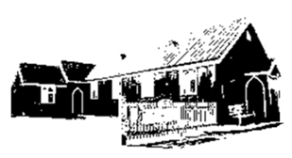  Date completed and notes

Please fill in this Covid-19 Risk Assessment prior to your activity and return it to di_johnstone@hotmail.com
Some areas or people at risk that you may wish to consider might include:
- Attendees of your activity and the necessity for keeping a register, maintaining social distance and regular use of hand sanitiser
- The main hall and the necessity for cleaning switches, handles and equipment prior to and after an activity
- ‘Pinch points’ and the necessity for people to use the toilet area one at a time and maintaining social distance at the hall entrance and exit

